**SQL ASSIGNMENT**

**QUERY – 01**

create database departments;

use departments;

create table items_list( name_of_items varchar(20) not null, rate_of_items int not null,customer_preference varchar (20) not null);

desc items_list;

select * from items_list;

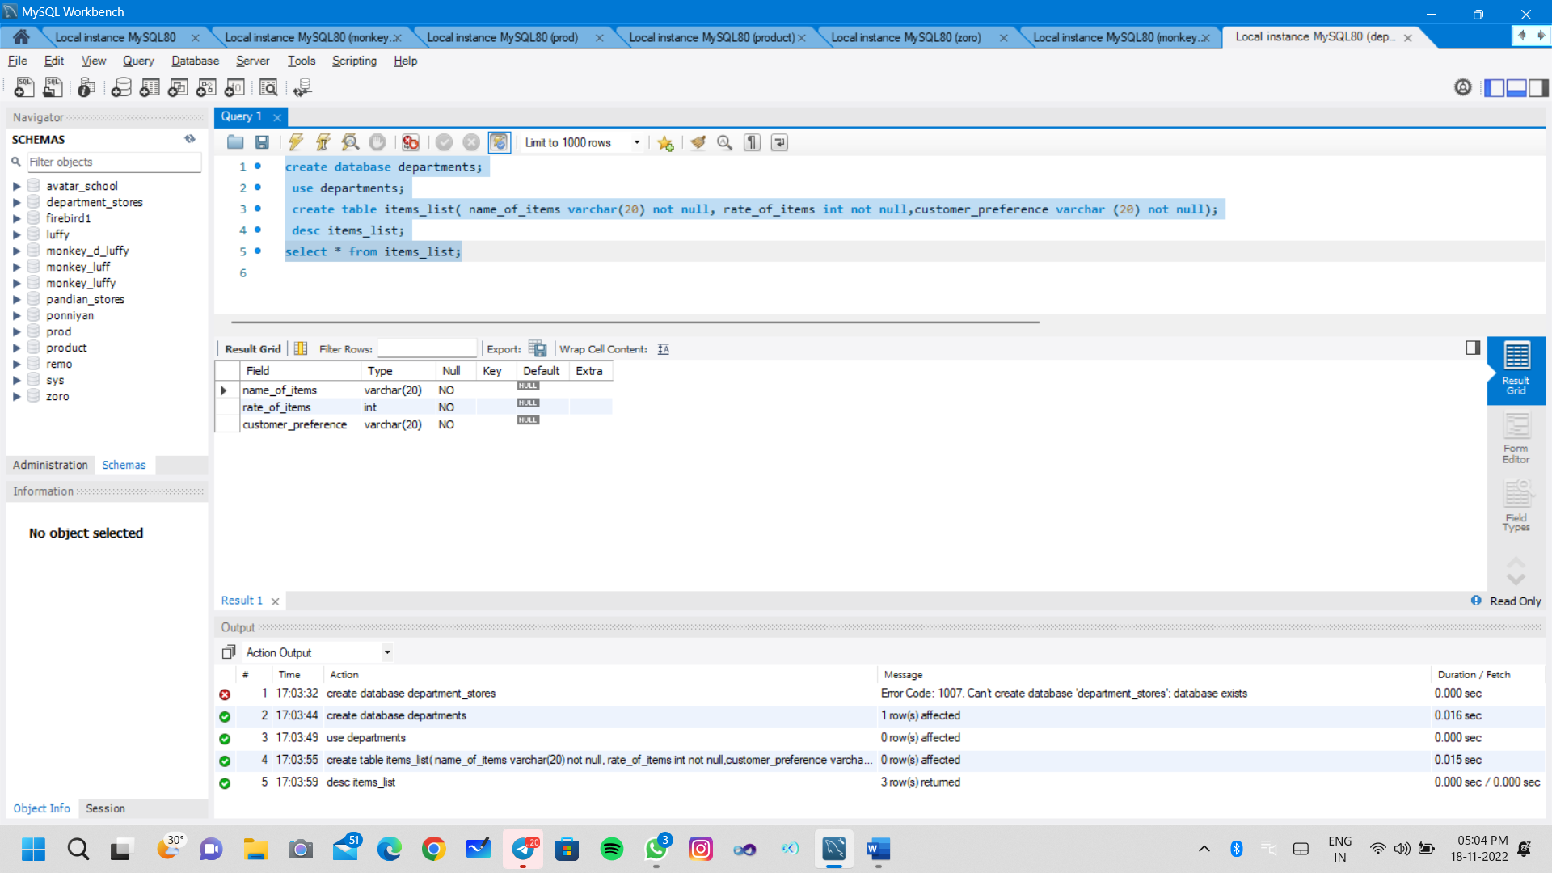

create database departmen;

use departmen;

create table itemss( name_of_items varchar(20) not null, rate_of_items int not null, customer_preference varchar (20));

INSERT INTO itemss(name_of_items,rate_of_items,customer_preference)

VALUES ('chocolate',2000,'mostly prefered'),

('biscuit',2500,'prefered'),

('chips',1000,'prefered');

select * from itemss;

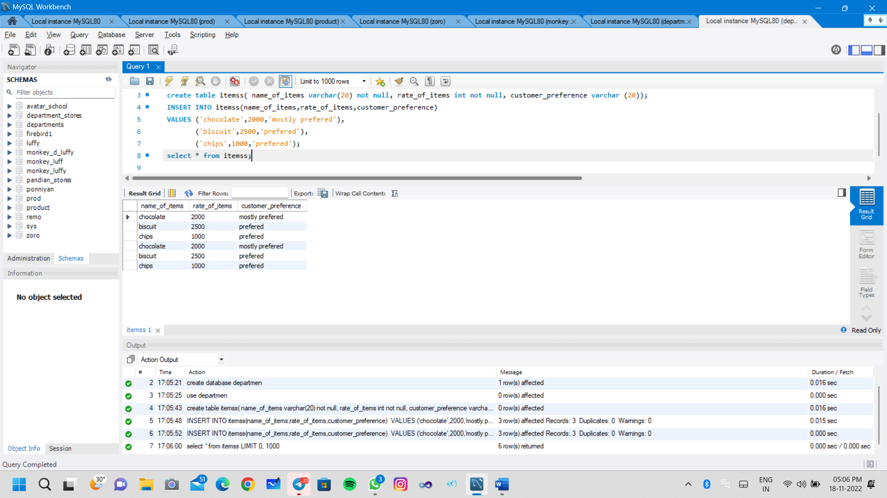

**QUERY - 02**

CREATE DATABASE monkey_luff;

USE monkey_luff;

create table Aadi_SALE (ID varchar(20), PNAME varchar(40), PRICE INT, QUANTITY INT);

INSERT INTO Aadi_SALE VALUES ('P01', 'MILK BISCUIT',20,1);

INSERT INTO Aadi_SALE VALUES ('P02', 'WHEAT',60,1);

INSERT INTO Aadi_SALE VALUES ('P03', 'RICE',113,8);

INSERT INTO Aadi_SALE VALUES ('P04', 'RAGI',96,4);

SELECT * FROM Aadi_SALE;

SELECT PNAME, PRICE*QUANTITY FROM Aadi_SALE;

create view Aadi_SALE_view as select pname,(price*quantity) as total from Aadi_SALE ;

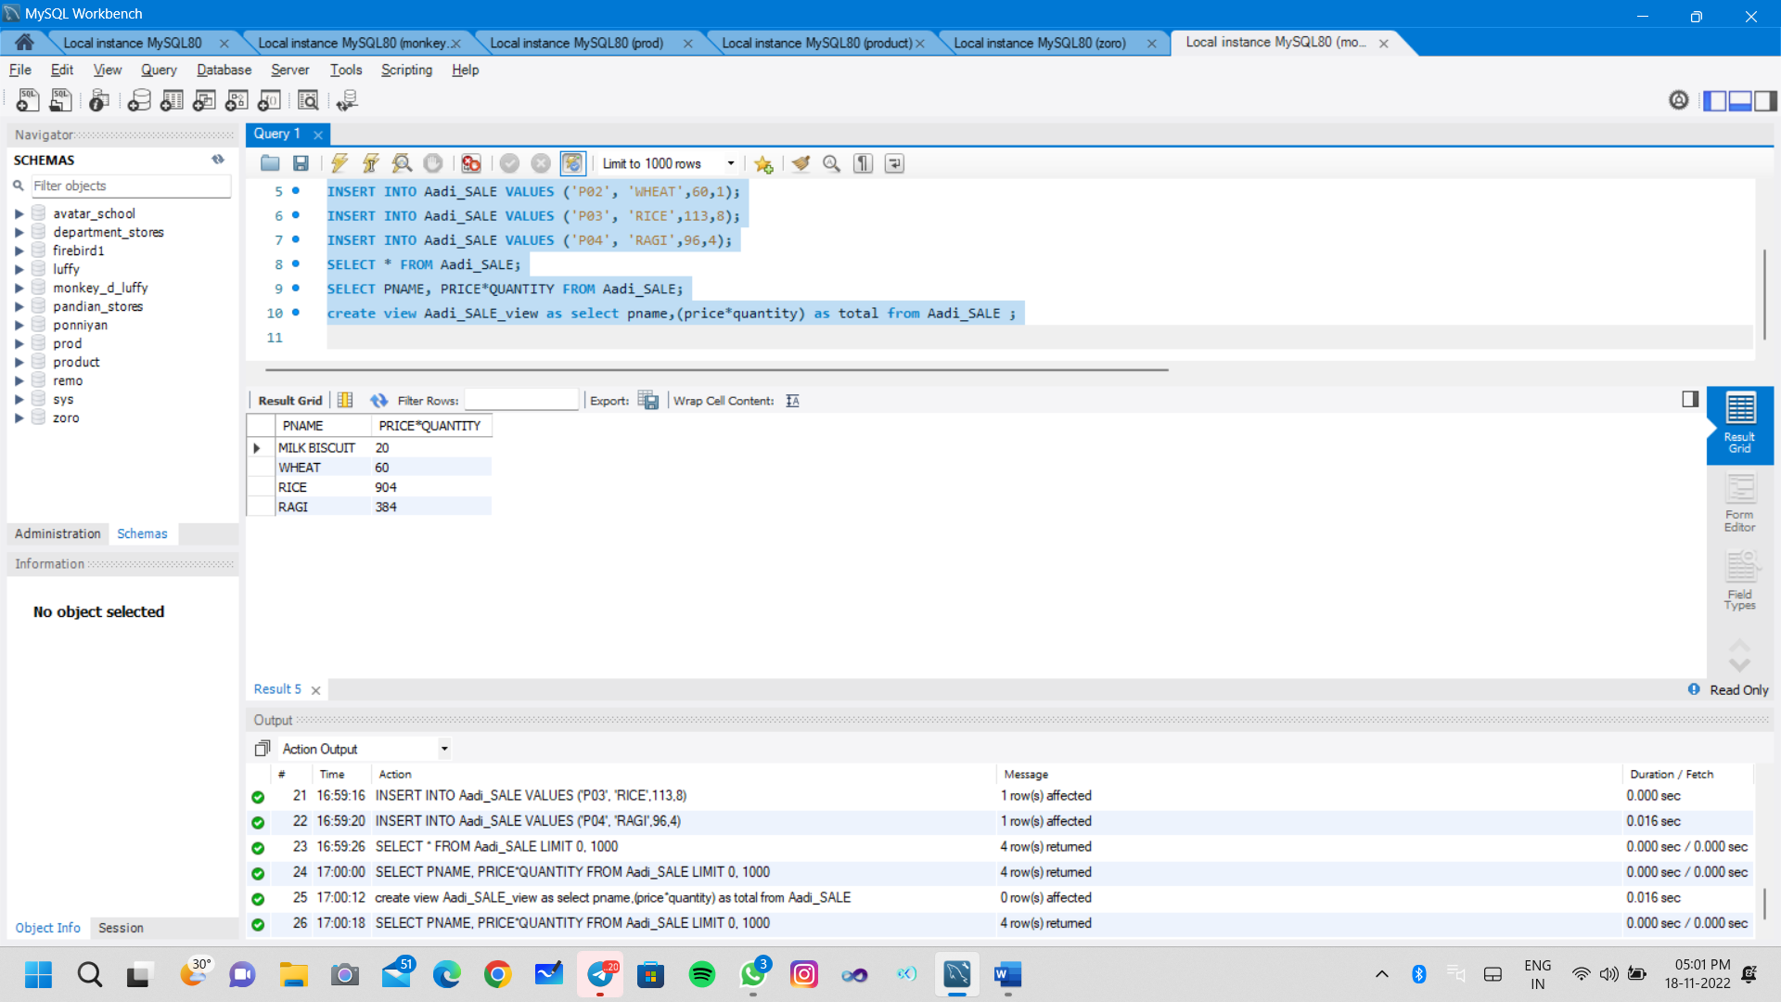

**Query – 03**

create database prod;

use prod;

create table students_inform(id int not null, Nam varchar(40) not null, age int not null);

INSERT INTO students_inform(id,Nam,age)

VALUES (1,'BOb',21),(2,'Sam',19),(3,'Jill',18),(4,'Jim',21),(5,'Sally',19),(6,'Jess',20),(7,'Will',21);

select *from students_inform;

select sum(age) from students_inform;

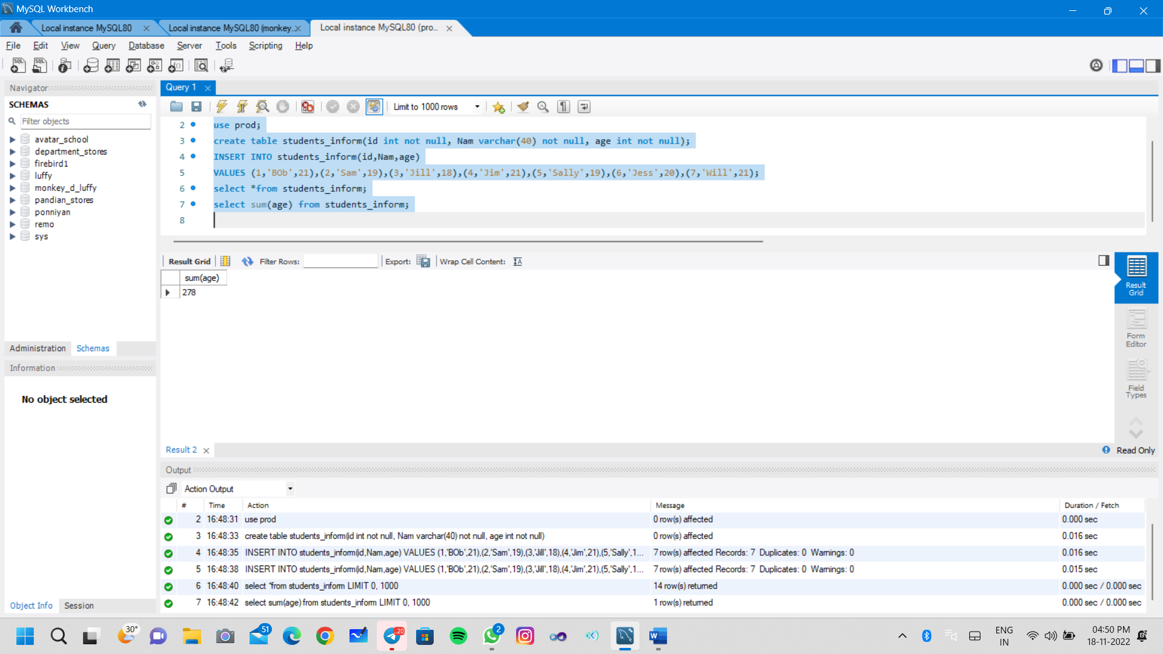

**Query – 04**

create database product;

use product;

create table students_infoma(id int not null, Nam varchar(40) not null, age int not null);

INSERT INTO students_infoma (id,Nam,age)

VALUES (1,'BOb',21),(2,'Sam',19),(3,'Jill',18),(4,'Jim',21),(5,'Sally',19),(6,'Jess',20),(7,'Will',21);

select *from students_infoma;

select age , count(*) as count_age from students_infoma group by age ;

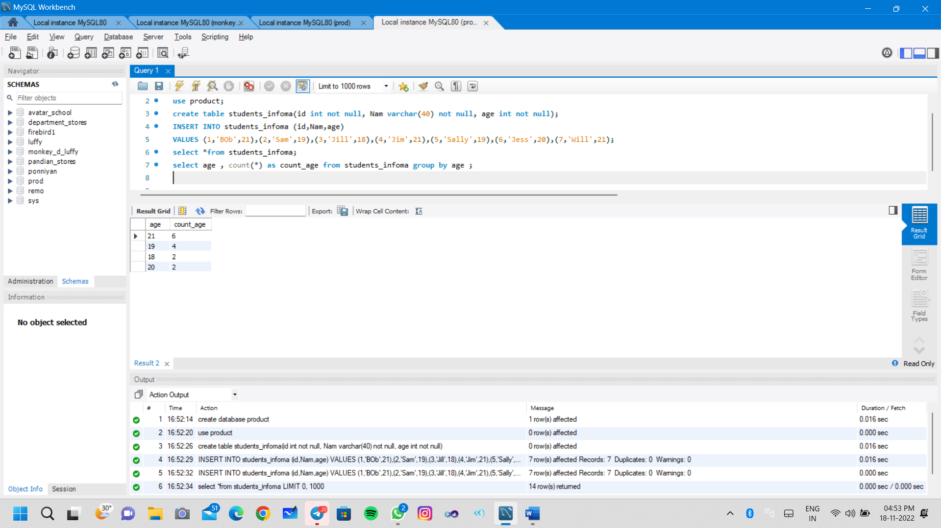

**Query – 05**

create database zoro;

use zoro;

create table luffy(Division_id int not null, years int not null, revenue float not null);

insert into luffy values(1,2018,60),(1,2021,40),(1,2020,70),(2,2021,-10),(3,2018,20),(3,2016,40),(4,2021,50);

select Division_id from luffy where revenue > 0 and years = 2021;

